How to duplicate an event

Event Creator Plus > Getting Started

- Go to your Dashboard of events ()
- Scroll to the event you would like to duplicate then from the action items available, click Duplicate.
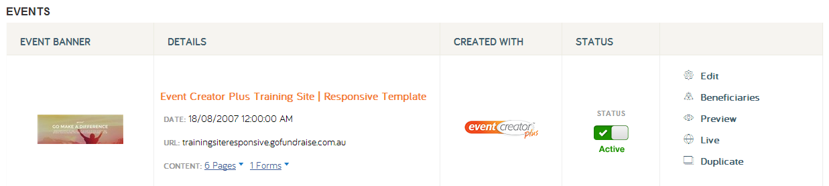
- When prompted add the new subdomain for your new event (one word using characters 0-9, a-z, and/or hyphens. No spaces). The subdomain of an event is the unique part of the Event URL e.g.in the event URL myevent.gofundraise.com.au, myevent is the subdomain. You can change the Event URL at a later stage if you need to. Uncheck the ‘Include Form’ check box if you do not want an existing registration form to be duplicated over as well (it is recommended to leave this box checked).
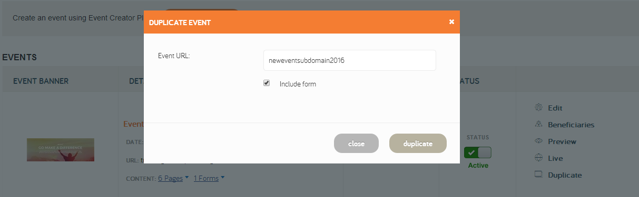
- Click Duplicate.
- Your new event will now appear at the top of your Dashboard of events, ready for you to edit.